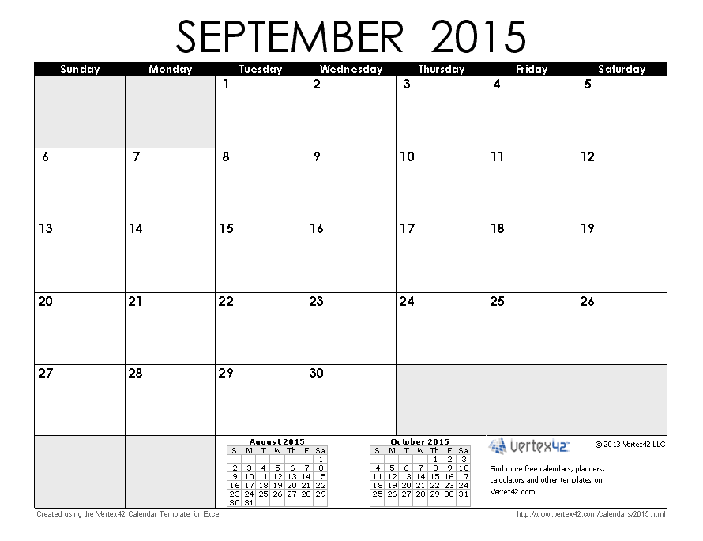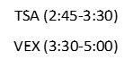

Joining Form/Money & FT PS DUE!

VEX (3:30-5:00)

OCTOBER

\*Meetings are subject to change. Listen for announcements and check Edmodo.

VEX (2:45-5:00)

First TSA Meeting ☺

(2:45-3:30)

VEX (3:30-5:00)